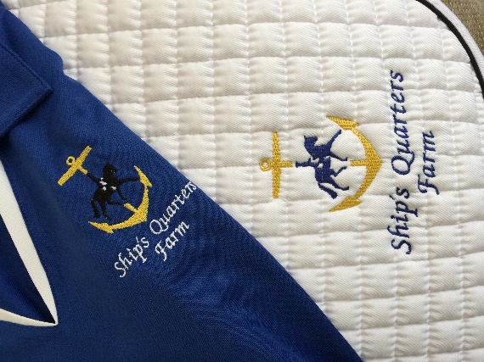**SHIPS QUARTERS FARM**

**~Dressage Show Series~**

**May 15, 2016 Sunday** - closing date May 1st

**July 24, 2016, Sunday** - closing date July 10th

**------------------------------------------------------------------------------------------------------------**

The judge for all shows will be Dona Ruth. Some entries may be her students.

**1.** Classes will be combined or split at the organizers discretion.

**2.** 2014 USEA (eventing) tests and the 2015 USDF & USEF Dressage tests will be used.

**3.** USDF Intro tests & USEA test Beginner Novice – Preliminary will be ridden in a small arena. USEF tests & USEA Intermediate & above to be ridden in large dressage arena.

**4.** **ALL COMPETITORS, GROOMS, ETC MUST WEAR HELMETS WHILE MOUNTED.**

**5.** A $30.00 fee will be assessed on all returned checks.

**6.** Class Fee $20.00 per class, ribbons awarded to 6th place; Juniors (13 & under as of 1/1/16)

**7.** Classes offered are:

**#1 USDF Intro A, B & C #7 USEA Novice A or B**

**#2 USEF Training Level 1, 2 & 3 #8 USEA Training A or B**

**#3 USEF First Level 1, 2 & 3 #9 USEA Preliminary A or B**

**#4 USEF Second Level 1, 2 & 3 #10 USEA Intermediate A or B**

**#5 USEF Third Level and above #11 USEA Advanced A or B**

**#6 USEA Beginner Novice A or B #12 Musical Freestyle or Pas de Deux\*** *must provide boombox

**8.** **!!!NO DOGS ALLOWED!!!**

**9.** Ride times will be emailed on the Thursday prior to the show.

**10.** To be eligible for the series end High Score champion, you must ride in two of the three shows. The rider/horse combination must remain the same. Each level/class will be eligible for the High Score champion.

**11.** Refund policy: After the closing date, no refunds will be issued, for any reason including cancellations due to acts of God, acts of terrorism, inclement weather and/or other emergencies. Any outstanding balances are still due; and will place you on a wait list for any future shows until your balance is taken care of.

**Come Join Us!!!**



**SQF Dressage Show Series**

**May 15, 2016, Sunday** - closing date May 1st

**July 24, 2016, Sunday** - closing date July 10th

Name:_____________________________________________________________________

Address:____________________________________________________________________ ____________________________________________________________________________

Phone (day)_________________________ Phone (cell)____________________________

IN CASE of EMERGENCY contact:_____________________________________________

Horse:_____________________________Rider:____________________________________

E-mail:_____________________________ Jr Riders birthdate:_______________________

*Juniors (13 & under as of 1/1/16) pinned separately.*

Show Date or Dates (circle): **May 15th July 24th**

|  |
| --- |
| Class # Dressage Test Fee ($20 per class)  ___________________________________________________________________________________  ___________________________________________________________________________________  ___________________________________________________________________________________  ________________________________________________________TOTAL$____________________ |

In signing this release form, I acknowledge that I am aware that horseback riding is a hazardous sport and that I participate at my own risk. I also agree to wear appropriate headgear at all times when mounted on the show grounds. I agree to hold harmless, Ship's Quarters Farm, LLC (their members, organizers, and staff) for any damages or injury to horses, persons or property of spectators or riders, whether such damages or injury be caused or alleged to be caused by the negligence of the LLC or any of the aforementioned parties, or by the negligence of any other persons, or any cause or causes. It is understood that participants and/or parents may be billed for damages to the show property due to carelessness.

___________________________________________________________ **Rider's signature** (parent or guardian if under 21)

**INSTRUCTIONS:**

**1.** Complete entry blank, negative Coggins within one year of show date & payment. Horse‛s name must be consistent throughout the show series & match coggins.

**2.** Enclose check payable to Ship's Quarters Farm

**3.** Refund policy: After the closing date, no refunds will be issued, for any reason including cancellations due to acts of God, acts of terrorism, inclement weather and/or other emergencies. Any outstanding balances are still due; and will place you on a wait list for any future shows until your balance is taken care of.

**4.** Mail completed entry to: Ship‛s Quarters Farm, 1665 Goldsmith Drive, Westminster, MD 21157